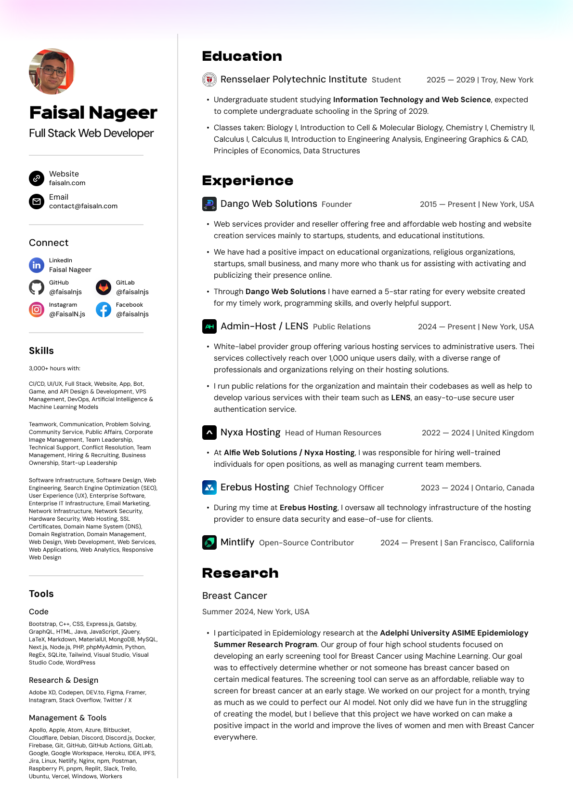
Hello! Please open this as a PDF to click links. https://faisaln.com/resume

